## Deploying a project in Amazon EC2

The following are the steps that are involved in the deployment process -

1. Create EC2 Instance on AWS
2. Connect to EC2 Instance using SSH
3. Cloning the Repo. on EC2
4. Building the App. Image using Docker
5. Running the Image using Docker
6. Access the Application on Browser using public IPv4 address

### Creating EC2 Instance on AWS

1. Launch AWS Console from the LMS Portal

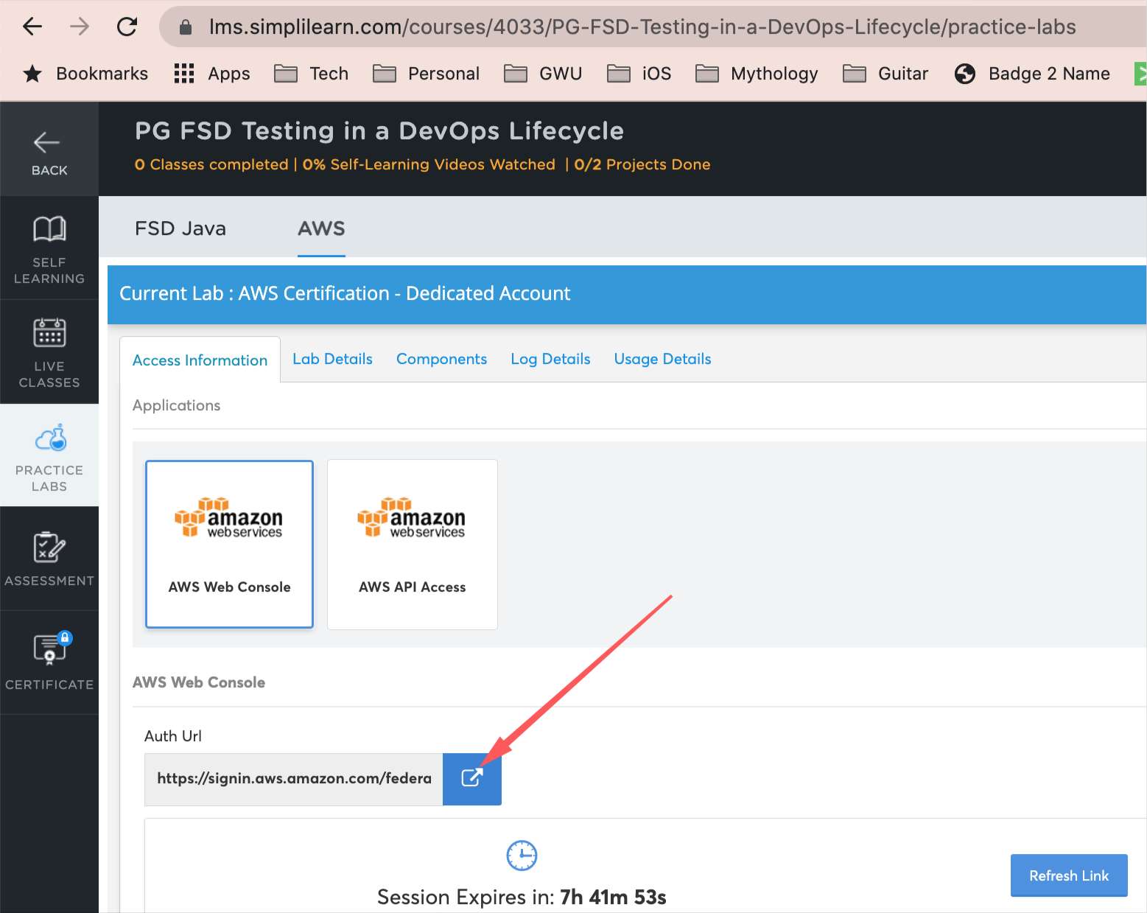

1. AWS Management Console - landing page

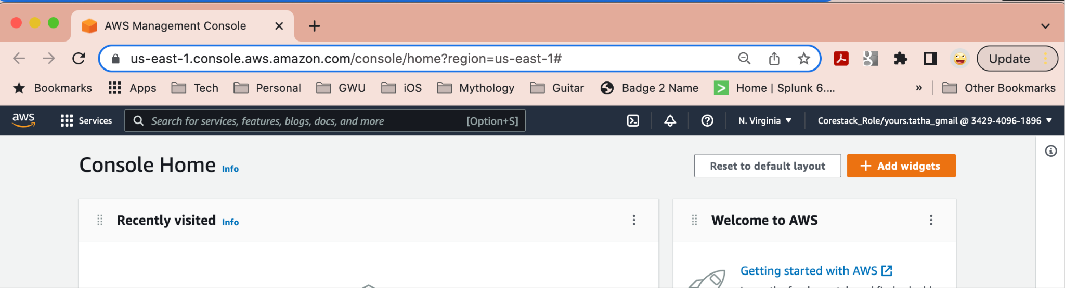

1. Click EC2 or search EC2 from the “Search Bar” on top

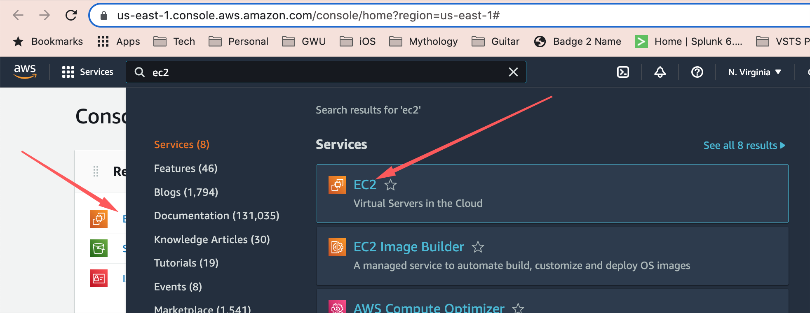

1. Click on “Instances”

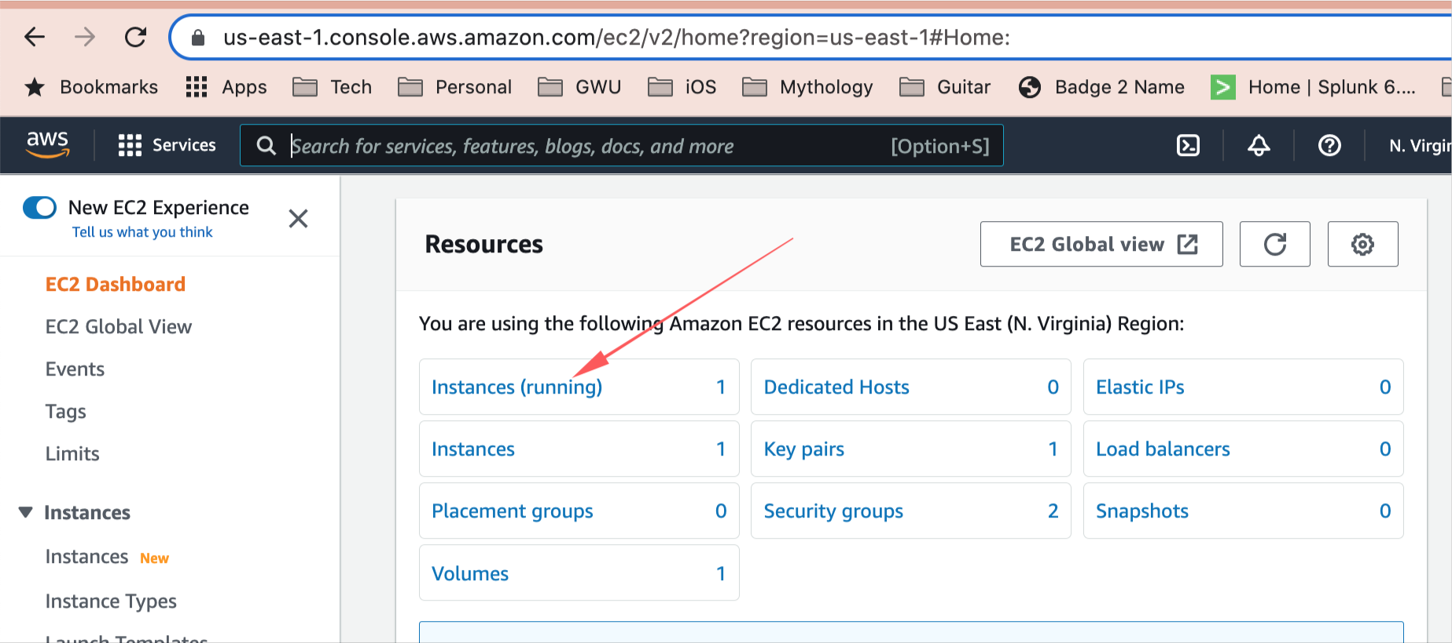

NOTE: We will be creating a New Instance for our deployment

1. Click on “Launch Instance”

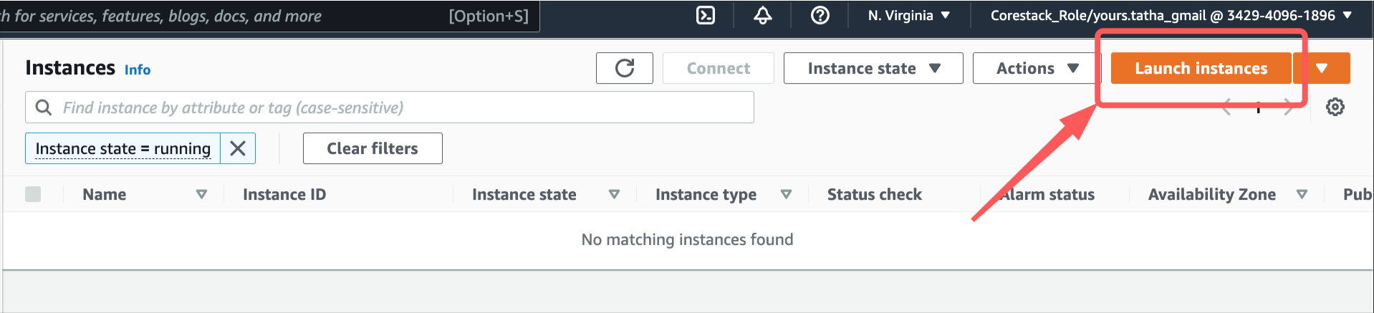

This will let us create a new EC2 Instance

1. EC2 Instance Creation
   1. Name-Tag

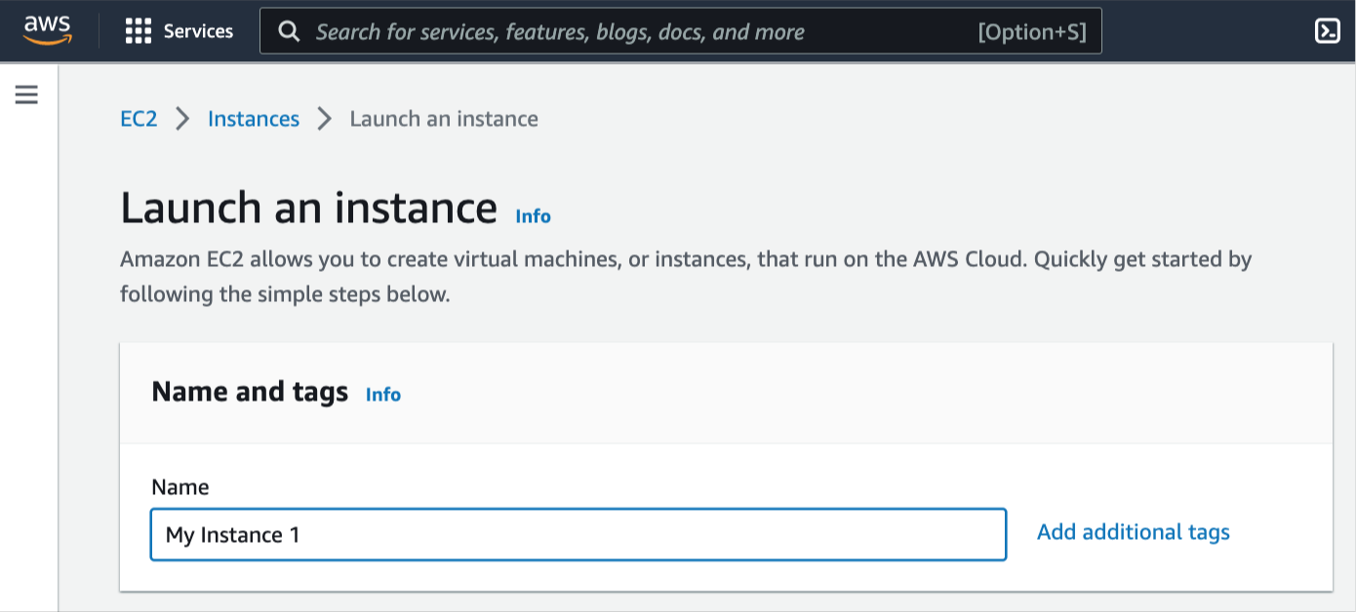

* 1. AMI Selection

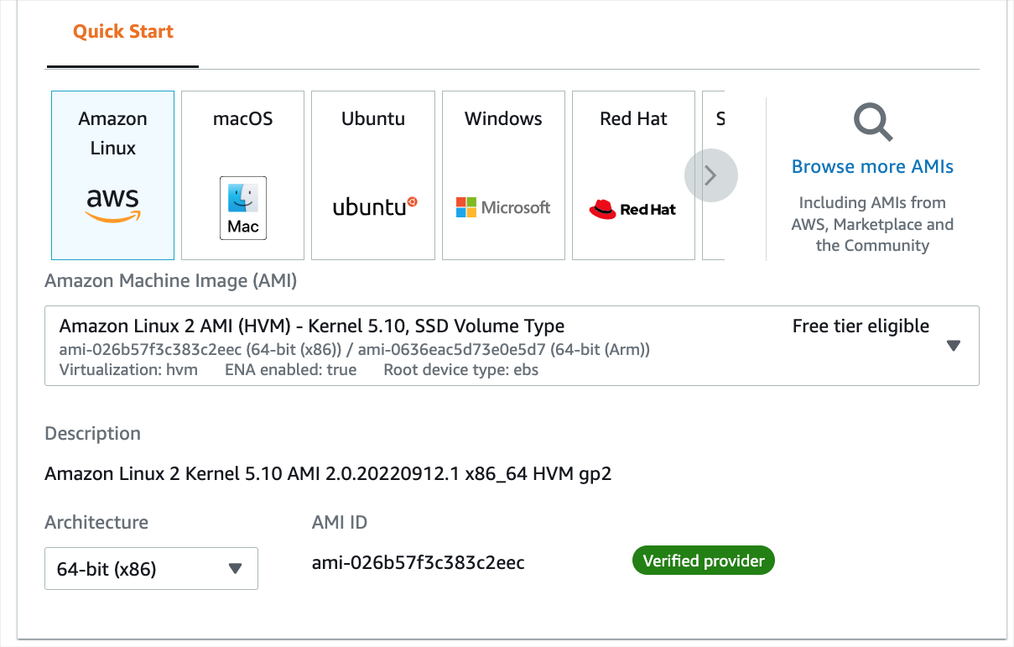

* 1. Instance Type

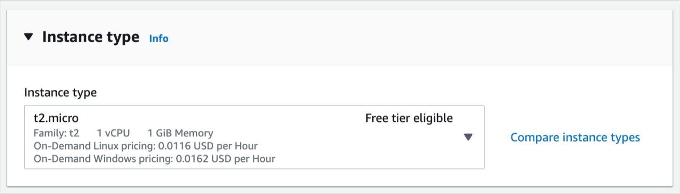

* 1. Key Pair

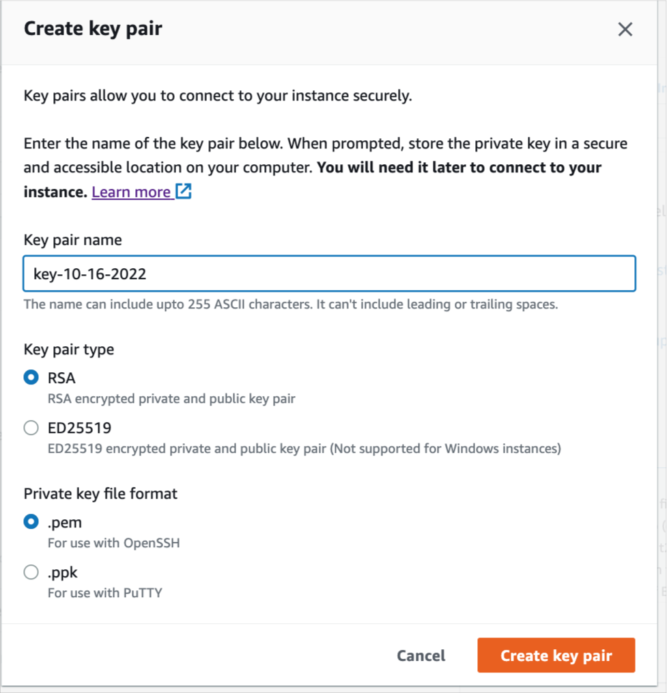

The key-pair is kept in a folder and will be used later.

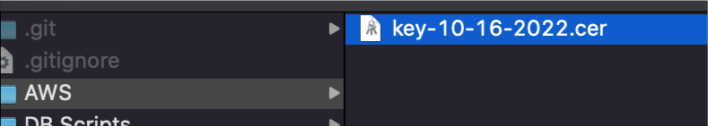

* 1. Network Details - leave defaults for now

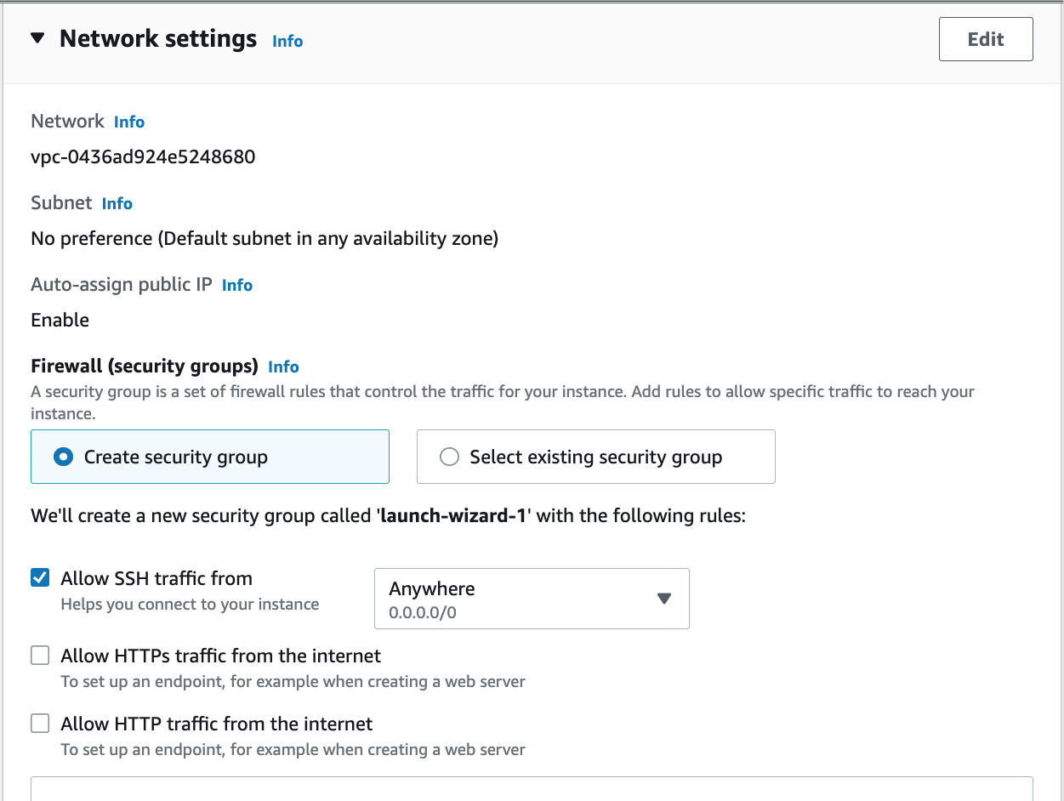

* 1. Storage - leave defaults

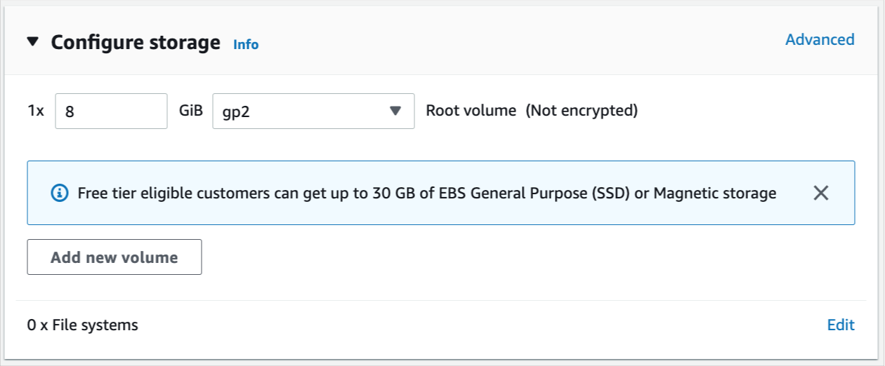

* 1. Advanced Details - leave as is

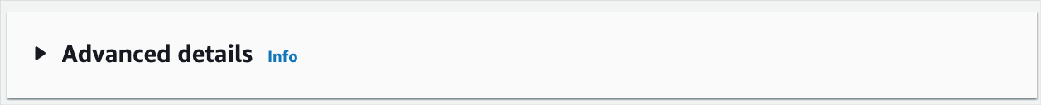

* 1. Click Launch Instance at the bottom right



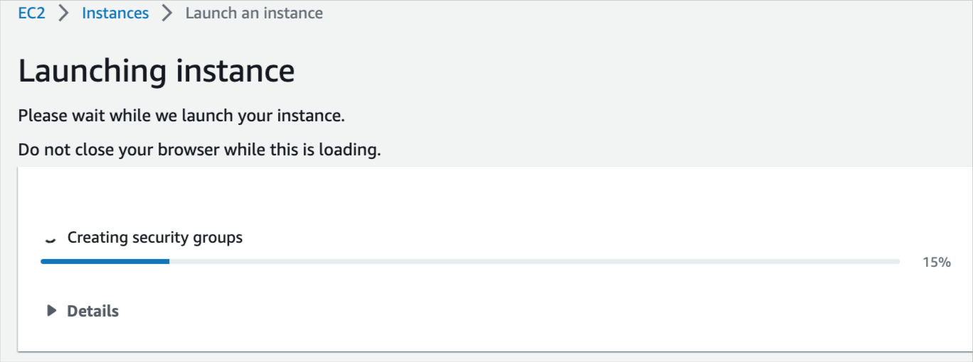

* 1. Check the instance from the EC2 Instances



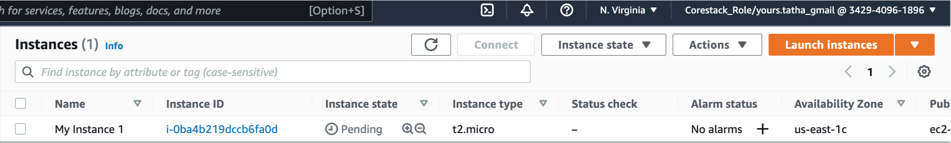

1. Connecting to the AWS EC2 Instance from Terminal/Command Line
   1. Open Terminal (or cmd line) at the location where the Key Pair was saved in the earlier step

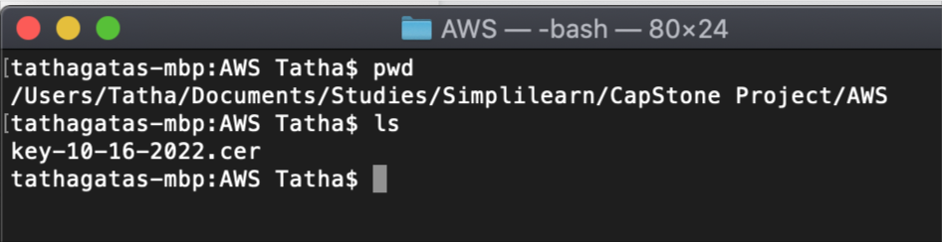

* 1. We need to change permissions on the Certificate file

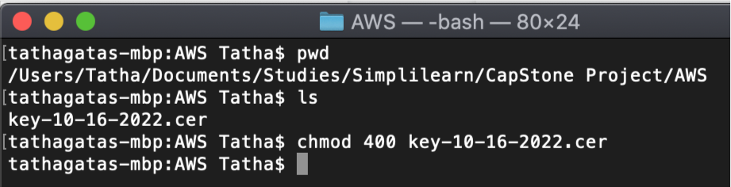

* 1. Select the Instance in the AWS Console and click on ‘Connect’

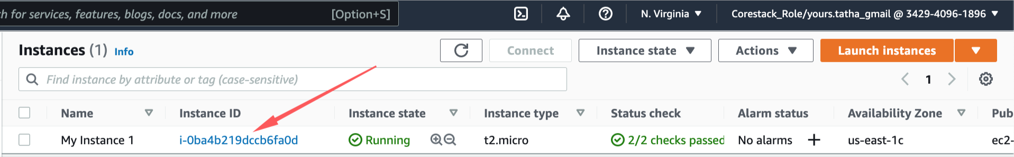

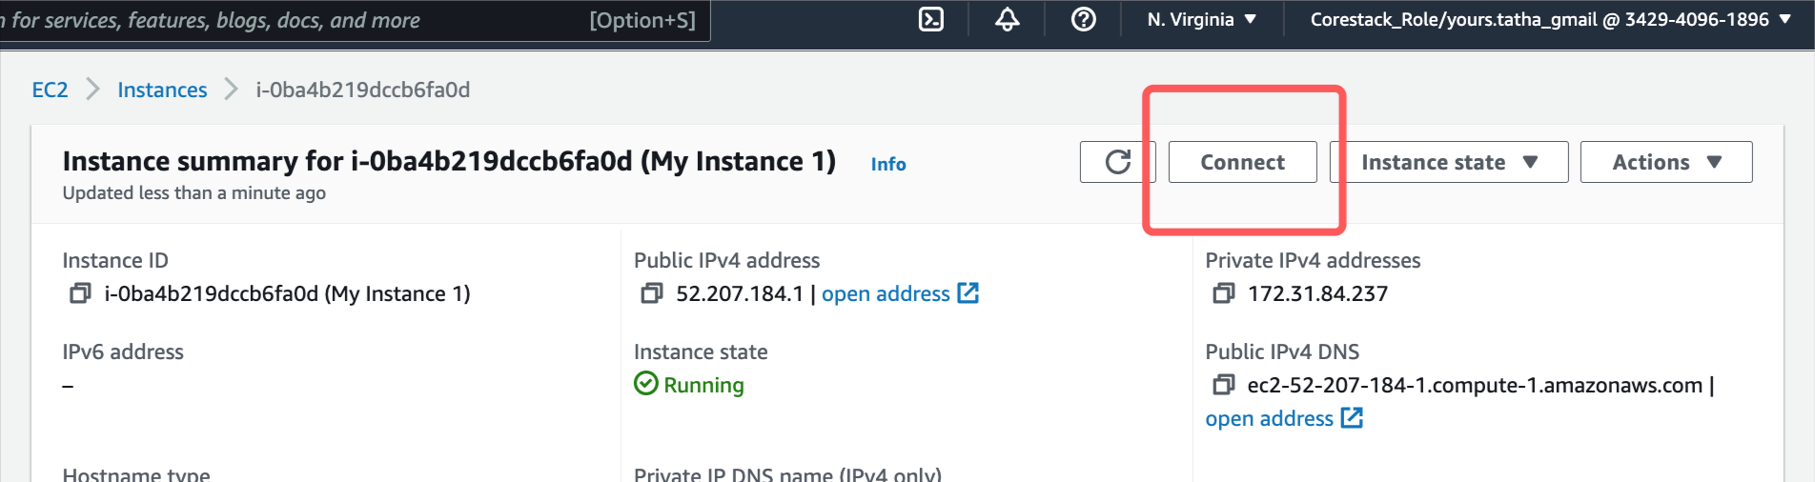

* 1. Go to the SSH tab and copy the statement

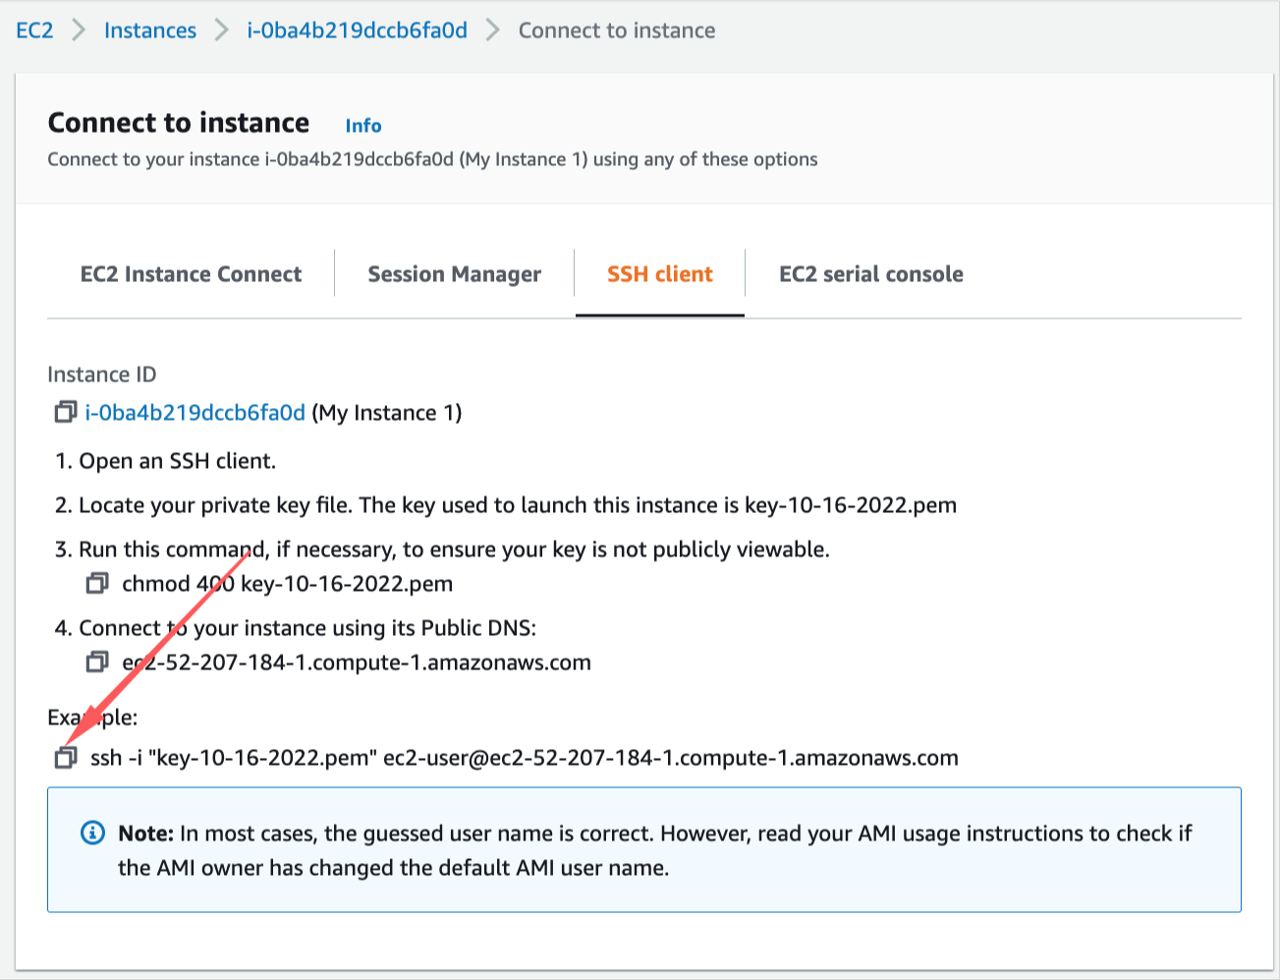

* 1. Enter the copied statement in the terminal (change .pem to .cer)

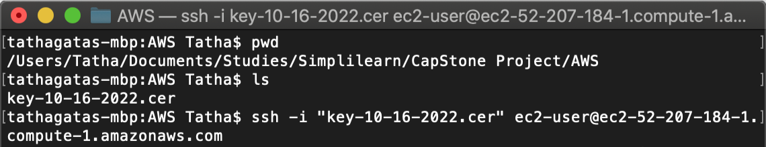

* 1. It works

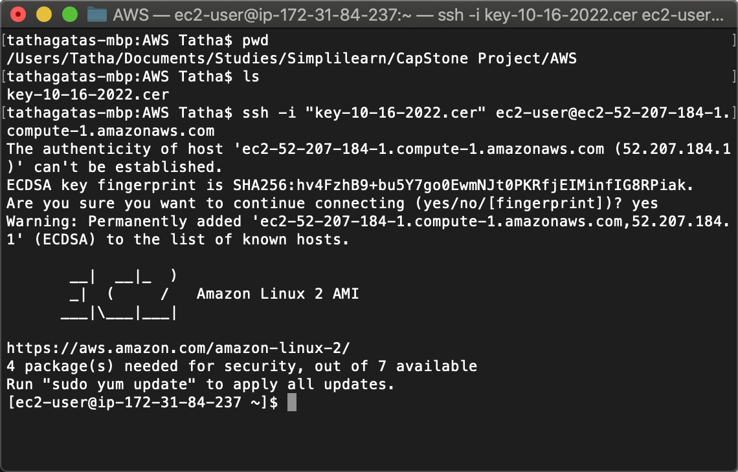

* 1. Install/Update Softwares
     1. Update the packages on your instance

sudo yum update -y

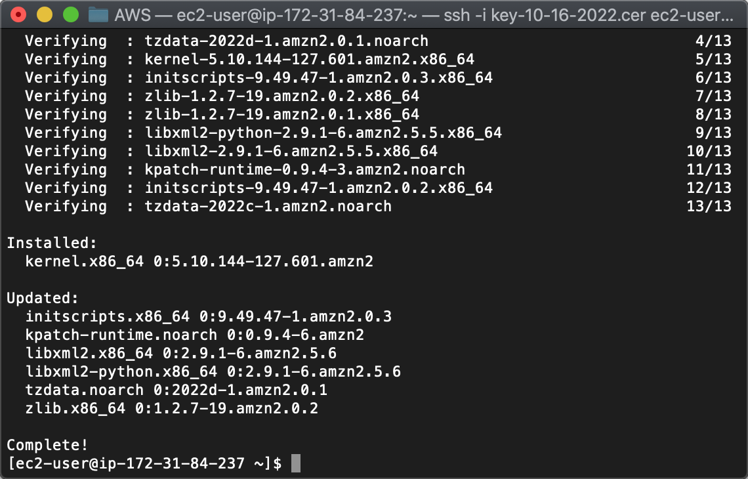

* + 1. Install git

sudo yum install git -y

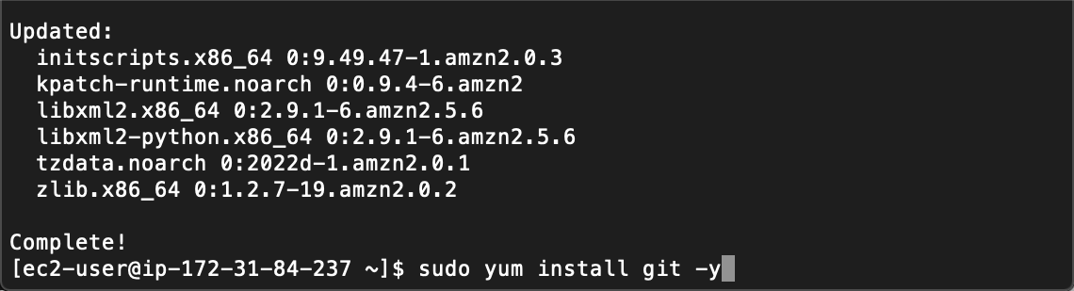

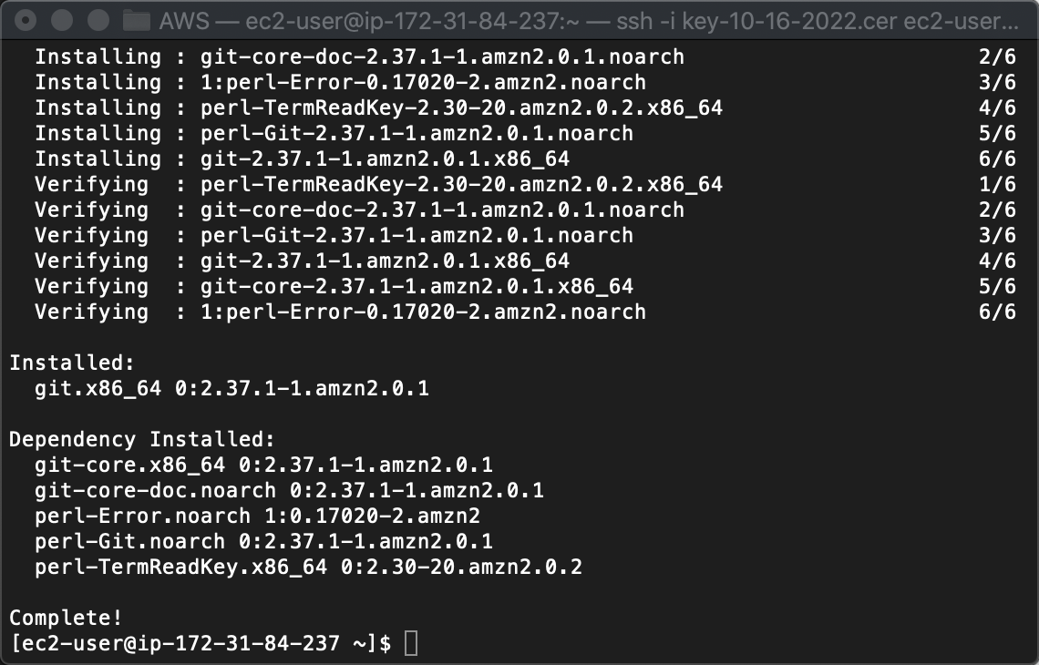

* + 1. Install Docker

sudo yum install docker -y

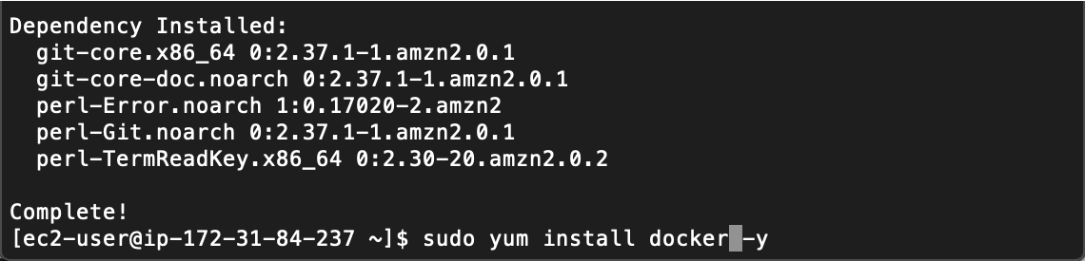

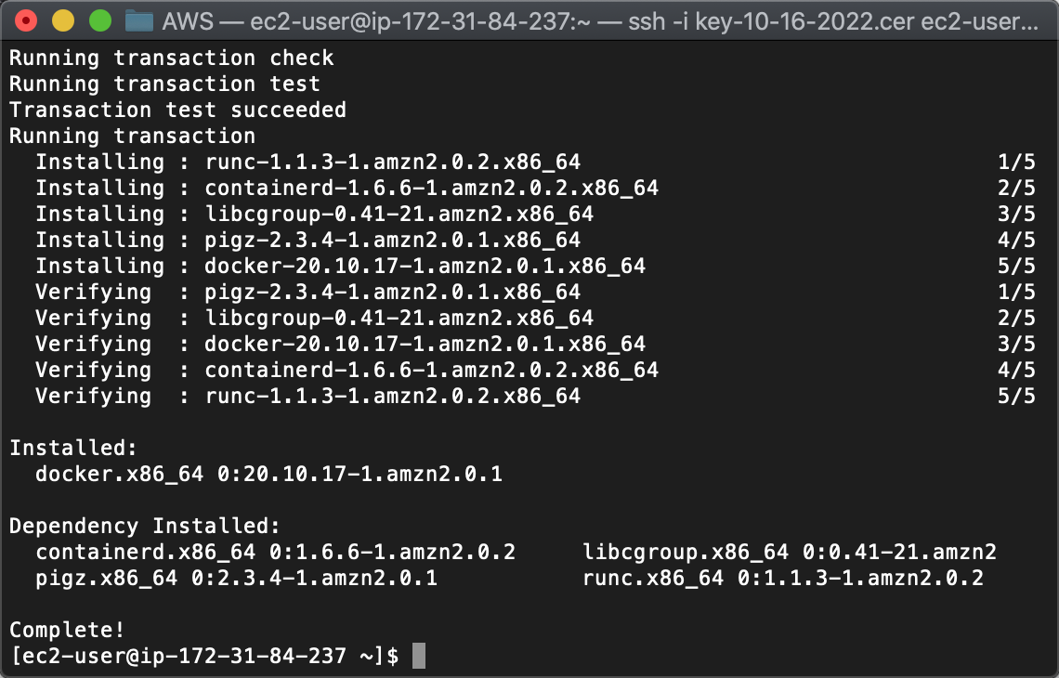

* + 1. Start Docker Service

sudo service docker start

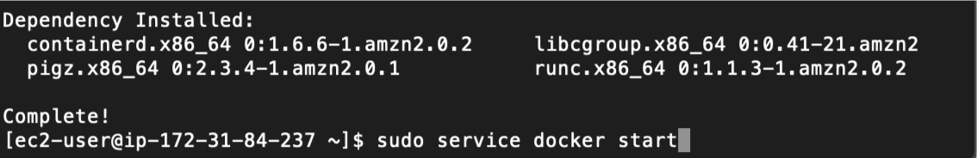

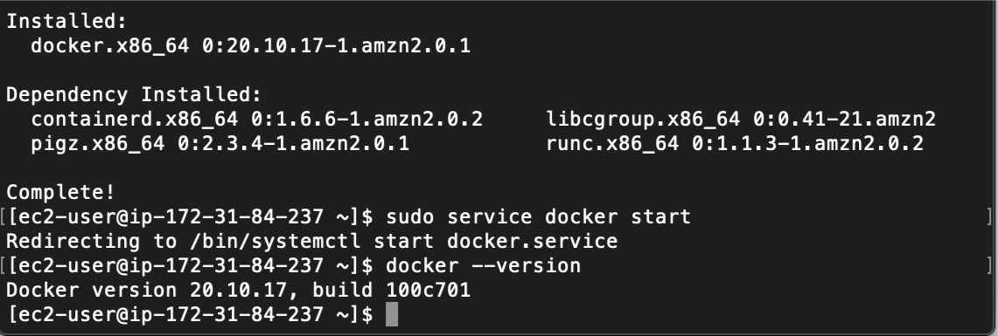

* 1. Install MySQL on Docker
     1. Pull the latest image

sudo docker pull mysql/mysql-server:latest

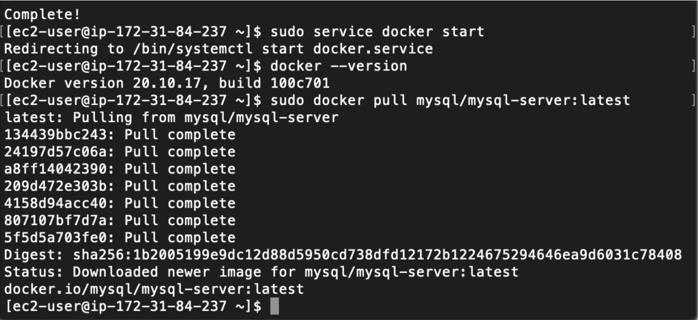

* + 1. Verify download

sudo docker images

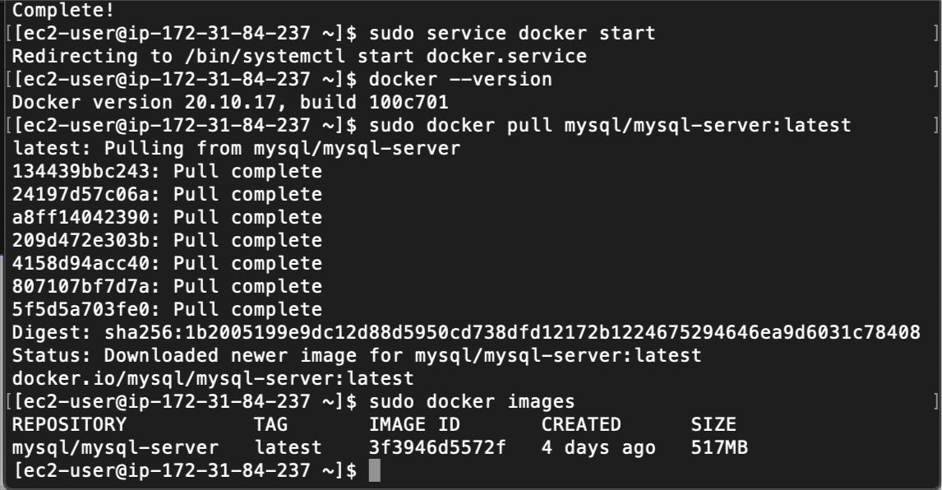

* + 1. Create a Docker Network for the Spring-Boot Application to communicate with the MySQL database

sudo docker network create mymovie-mysql-network

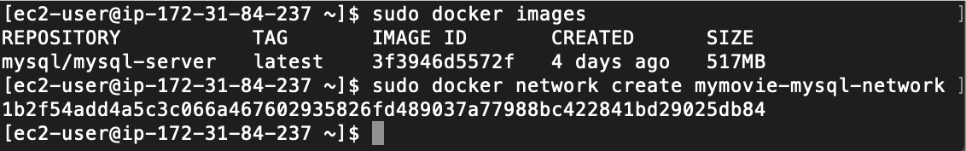

* + 1. Verify Network

sudo docker network ls

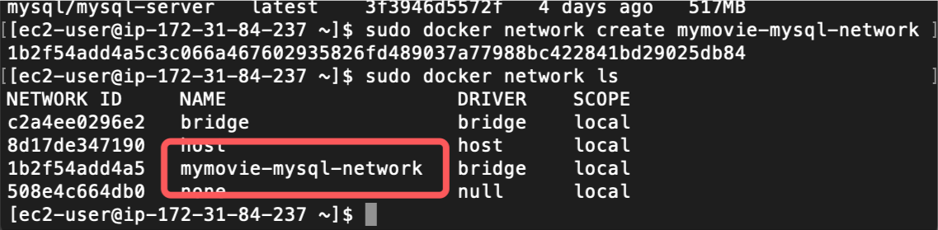

* + 1. Run the MySQL container in the network

sudo docker run -it --name mysqldb --network=mymovie-mysql-network -e MYSQL_ROOT_PASSWORD=OMGPassword! -e MYSQL_DATABASE=CAP_PROJ_MY_MOVIE_PLAN -e MYSQL_USER=admin -e MYSQL_PASSWORD=AdminSupreme -d mysql/mysql-server:latest

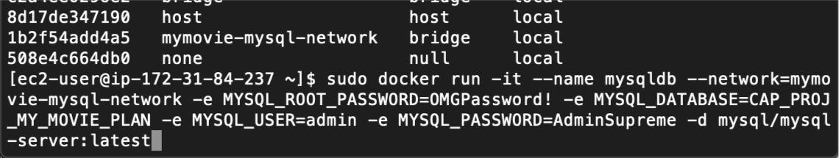

* + 1. Validate

sudo docker ps -a

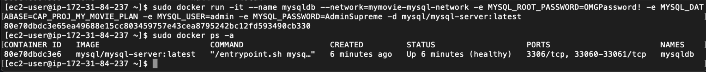

* + 1. We will connect with the root user

sudo docker exec -it mysqldb mysql -uroot -p

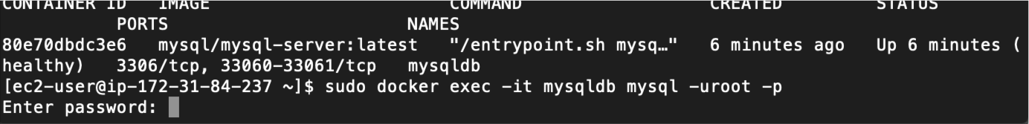

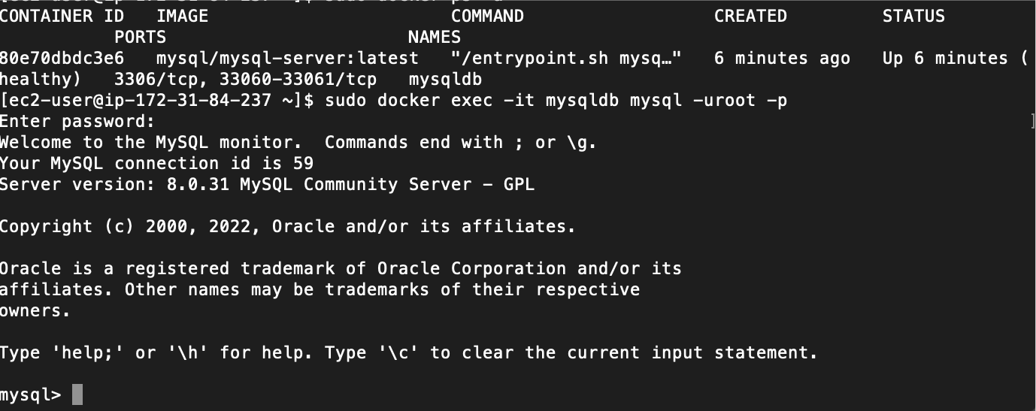

* 1. Download from GitHub
     1. Connect to a new AWS CLI

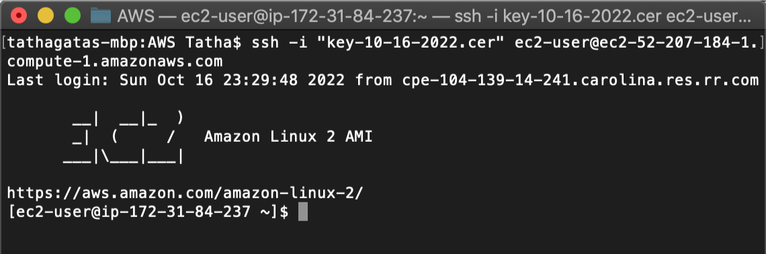

Create a new folder and initialze git

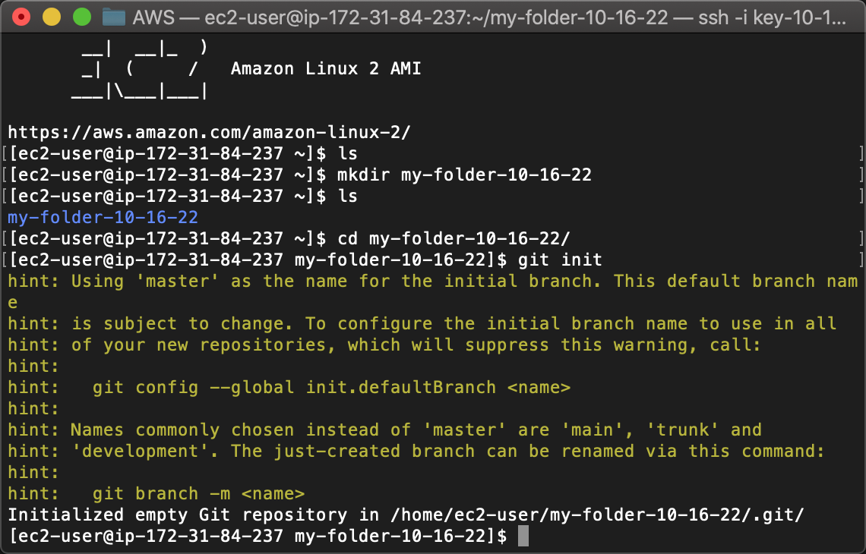

* + 1. Create a new folder; Set Remote; Pull; Checkout

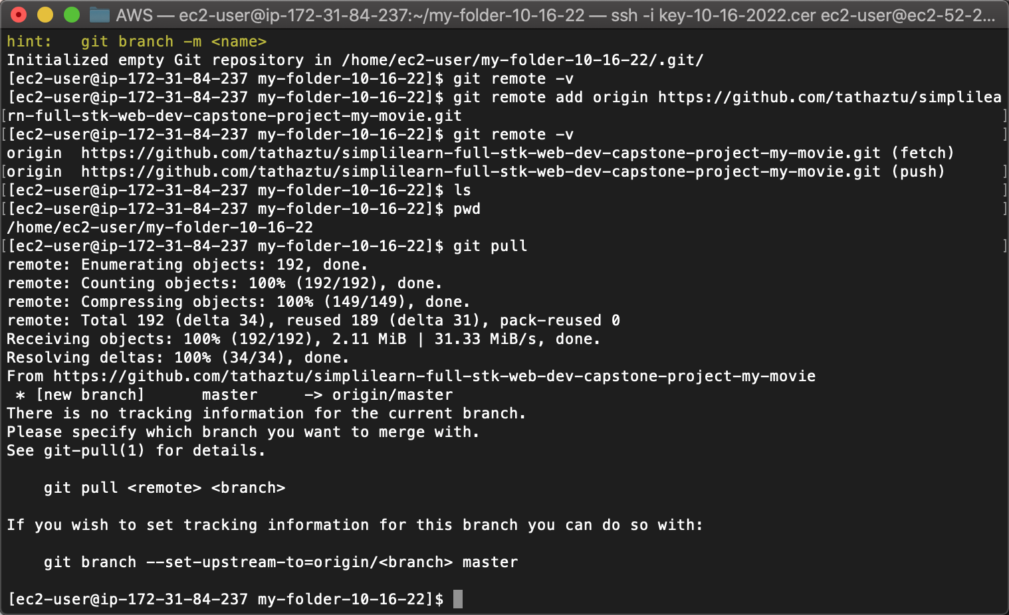

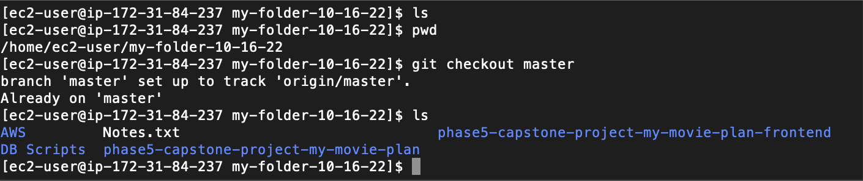

At the end of this step, artifacts would be downloaded from -

<https://github.com/tathaztu/simplilearn-full-stk-web-dev-capstone-project-my-movie> to the EC2 Machine

1. Run SQL Scripts
   1. Run DDL

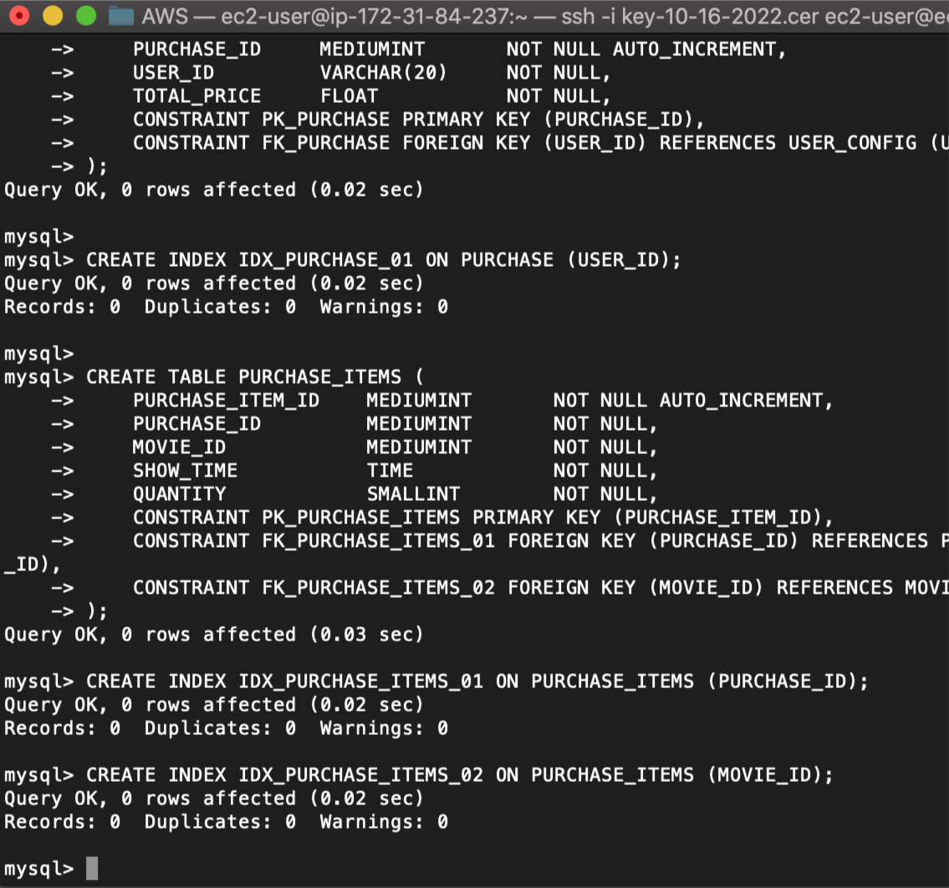

* 1. Run DML

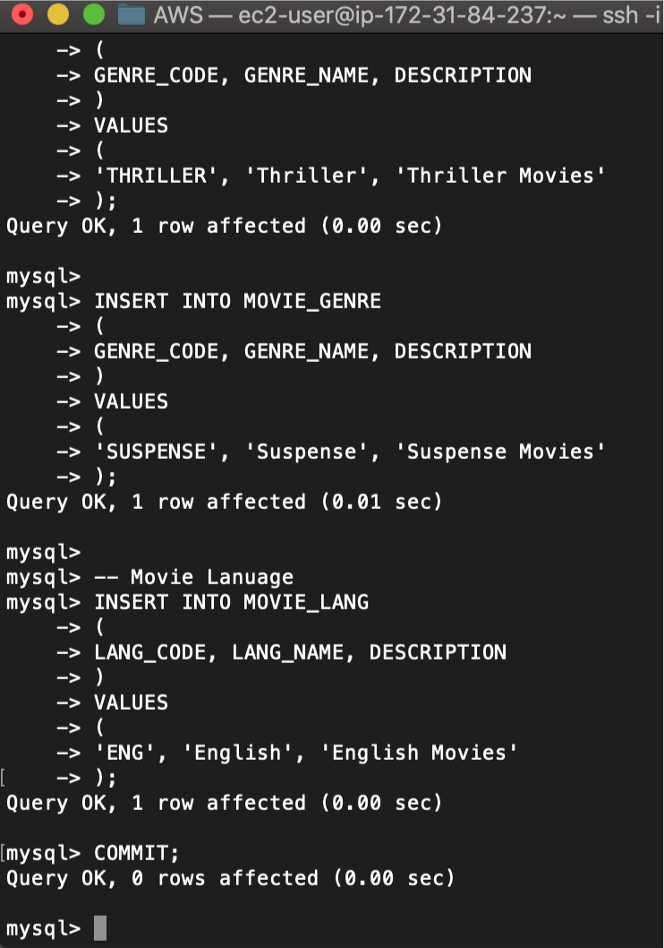

1. Run Docker Build

sudo docker build -t projectimage .

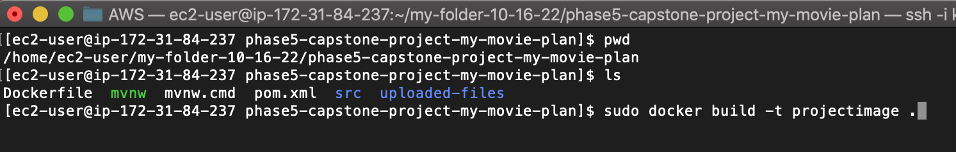

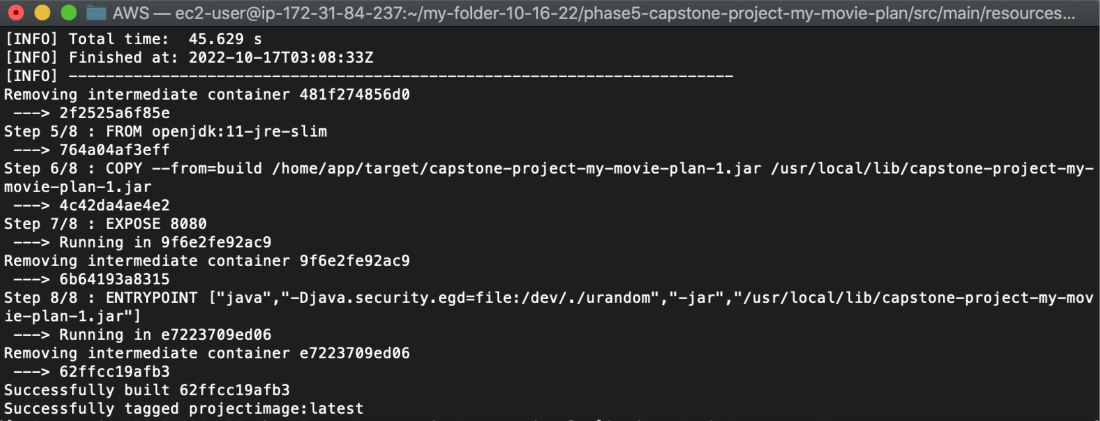

1. Validate

sudo docker images

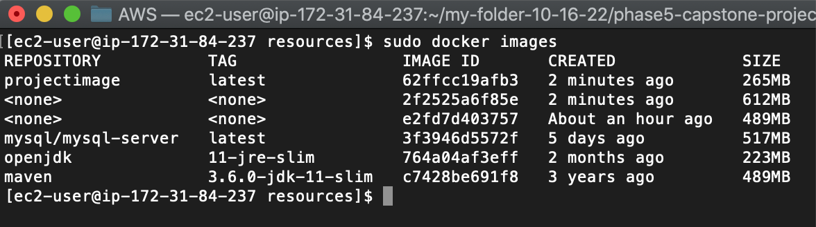

1. Run the Spring Boot Application

sudo docker run --network=mymovie-mysql-network --name mymovie-springboot-container -p 8080:8080 -d projectimage

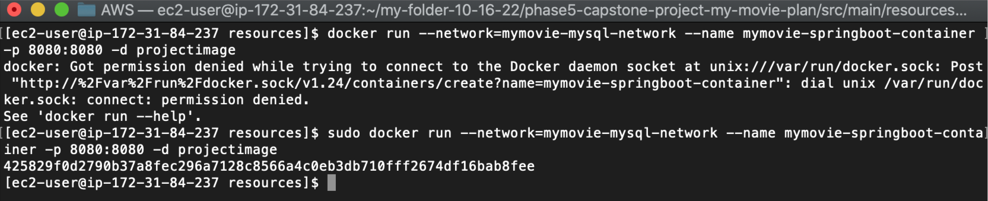

1. Assign permissions
   1. Go to the security settings for the EC2 Instance

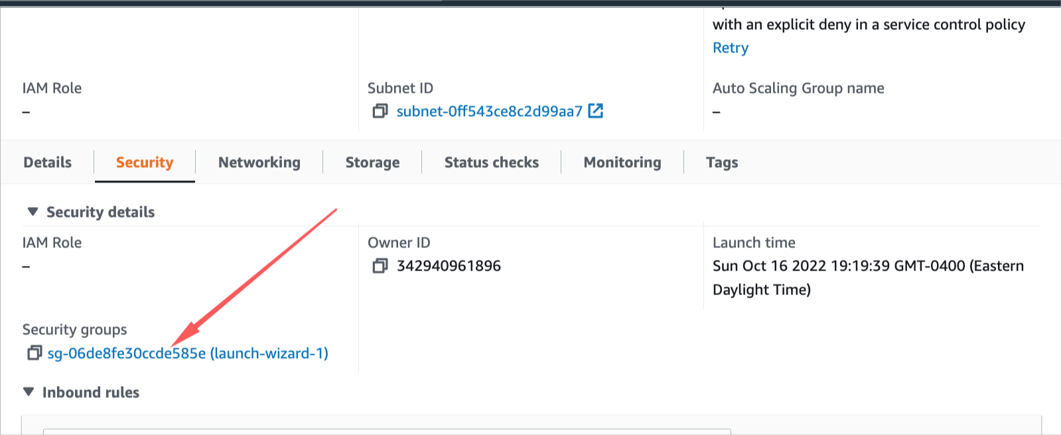

* 1. Edit Inbound Rules

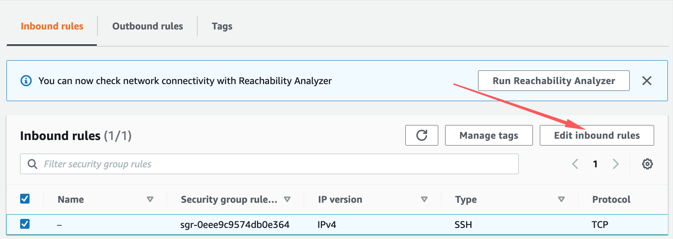

* 1. Add a line for ‘All Traffic’, ‘Anywhere IPv4’

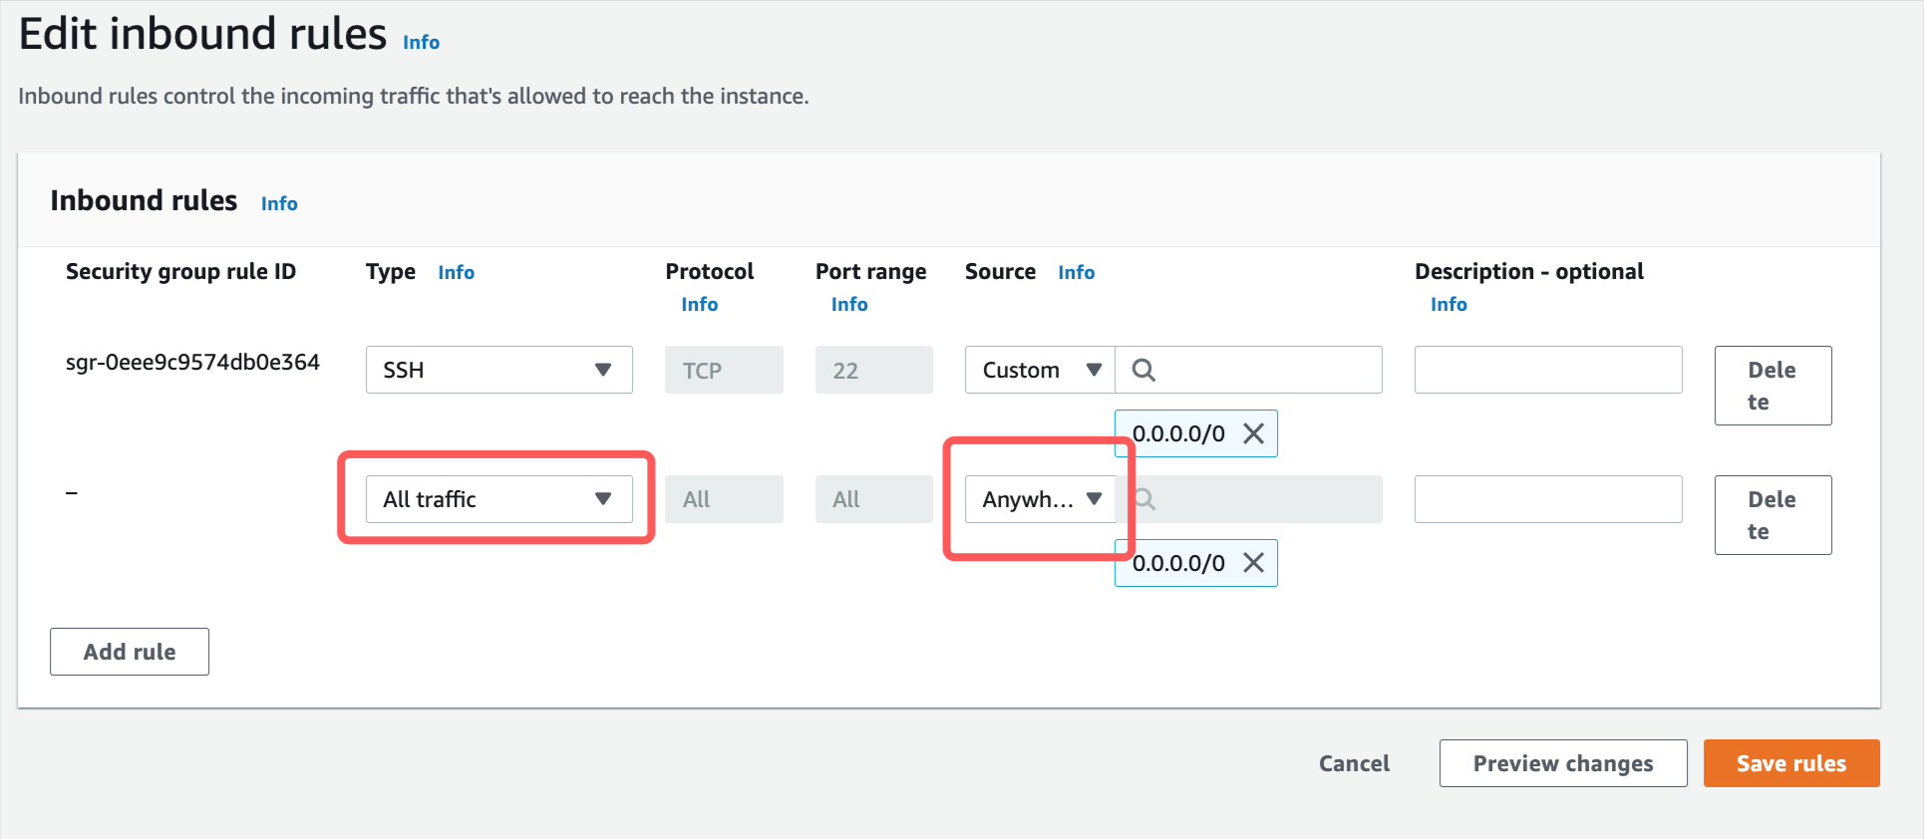

1. Access the Application
   1. Copy the public ip address

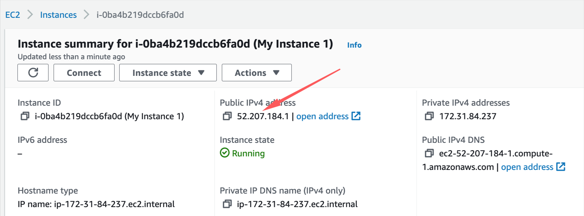

* 1. Invoke from Postman using the ip address